Tableau Story Design - EV Market Insights
Date | 29 October 2026
Team ID | Individual Project - Ujjawal Rathod
Project Name | Electric Vehicle Market Performance & Insights
Maximum Marks | 5 Marks

Story purpose
The Tableau Story converts the nine dashboard worksheets into a narrative for three stakeholder personas. The sequence starts with a market overview, then explains the strategic, competitive, and sustainable-mobility questions in a progressive order.
The story flow illustration is a design plan. Use the existing published Tableau Story link for live evidence and verify all observations against the current workbook before submission.
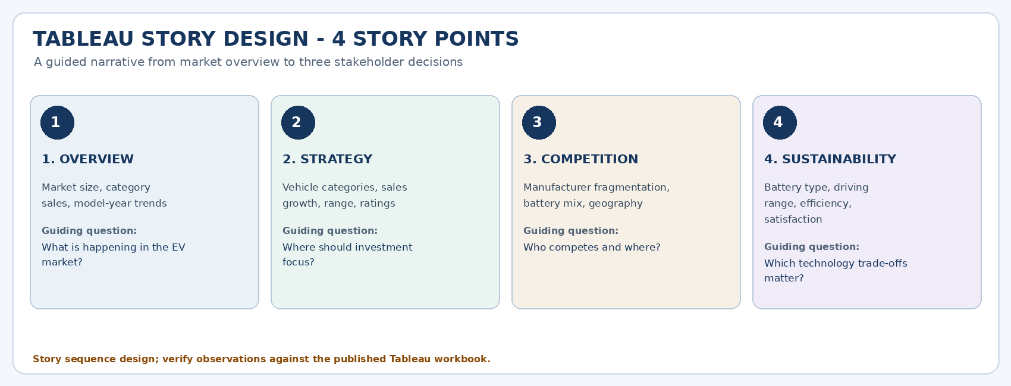

Story point plan
Story point | Audience / content | Key worksheets | Narrative question | Takeaway to validate
1. Market Overview | All stakeholders; scope, sales category mix, model-year trend and regional view. | EV Sales by Category; Sales Trend by Model Year; Sales by Region | What does the overall EV market look like? | The overview identifies the sales mix, time pattern and regional distribution.
2. Market Strategy - Emily Johnson | Portfolio and budget priorities. | EV Sales by Category; Top Manufacturers; Average Range by Category; Customer Ratings | Which categories and trends merit commercial focus? | Category demand and range/satisfaction should be considered together before changing investment.
3. Competition & Geography - David Chen | Competitor fragmentation, battery adoption, manufacturing countries and regions. | Top Manufacturers; Market Share %; Battery Mix; Country x Region Heatmap | How is competition distributed, and where are manufacturing and market activity concentrated? | Prior summary indicates about 200 manufacturers and a leading share around 0.6%; validate the market-share denominator and geographic totals.
4. Technology & Sustainability - Dr. Sarah Williams | Battery types, driving range, energy use and ratings. | Battery Mix; Range by Category; Range vs Energy Consumption; Customer Ratings | Does chemistry affect range and the customer experience? | Prior summary suggests category explains much of the range spread and customer ratings are clustered around 4.08-4.09/5; verify in workbook.

Storytelling and interaction rules
• Each story point should have a short title, one guiding question, and no more than two takeaway sentences.
• Maintain consistent colors for battery types and vehicle categories across every story point.
• Use annotations only when the underlying data supports the claim; label historical/model-year coverage.
• Keep shared filters consistent where possible and explain when a fixed market-share denominator is unaffected by filters.
• End with a decision-oriented summary and avoid claiming causality from simple descriptive comparisons.
Publish / view the Tableau Public Story: https://public.tableau.com/app/profile/ujjawal.rathod4051/viz/ElectricVehicleMarketPerformanceInsights_17931389708610/EVMarketStory

Public URL field for submission (confirm it opens without sign-in restrictions):
https://public.tableau.com/app/profile/ujjawal.rathod4051/viz/ElectricVehicleMarketPerformanceInsights_17931389708610/EVMarketStory

